Slide 1 | Cybersecurity Overview
TARGET: 3:00 | FOUNDATIONAL CYBERSECURITY / GUIDED TRANSITIONS
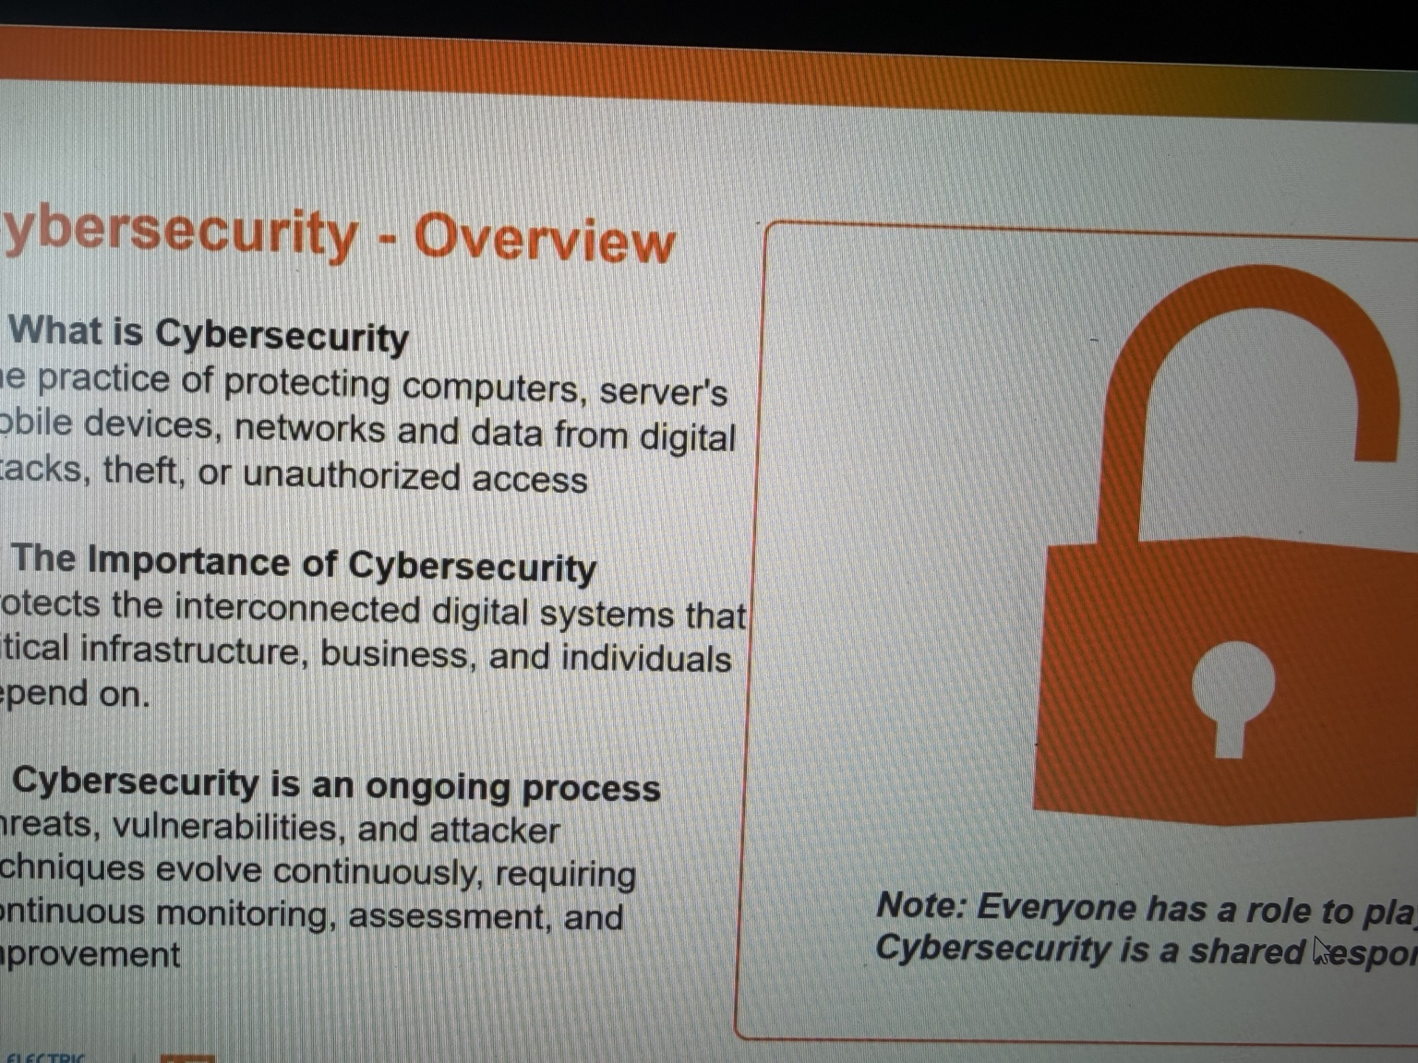

GENERAL TALKING POINTS
- Cybersecurity protects people, information, devices, networks, and the services organizations rely on.
- It addresses unauthorized access, data exposure, manipulation, fraud, and disruption.
- Use an everyday scenario: a convincing login email, stolen credentials, and the possible business consequences.
- Security is an ongoing cycle of prevention, detection, response, and recovery.
- Transition question: What exactly are we trying to preserve when we protect a system?

PRESENTER SCRIPT / NOTES
0:00–0:45 | Define cybersecurity and the problem it solves
Cybersecurity protects information, networks, devices, and the systems people rely on from unauthorized access, misuse, alteration, and disruption. Think about an ordinary organization: email, employee accounts, financial records, customer services, and applications that staff need to do their jobs. Each has value, whether that is information, money, a business process, or trust. Cybersecurity is more than installing antivirus software. It means deciding who should have access, what they can do, how we recognize suspicious activity, and how we recover when something goes wrong. An incident might be intentional, such as phishing, or accidental, such as sharing a sensitive document with the wrong person.
0:45–2:15 | Scenario: a routine message becomes an incident
Consider an employee who receives an email saying, 'Your account will be suspended today unless you verify your password.' It uses a familiar logo and appears to come from the help desk. The employee clicks the link and enters a password into a fake sign-in page. Nothing unusual happens on their screen, but the attacker may now have their credentials. What can that account reach? If it can access only one limited application, the damage might be contained. If it can access email, shared files, or financial systems, an attacker may read messages, impersonate the employee, or attempt further access. Imagine a fake email asking accounting to update a vendor's bank details. That creates the possibility of fraud without anyone touching the employee's computer. Or imagine ransomware encrypting a shared file system. Staff can no longer complete ordinary work, and customers may not receive service. One click does not automatically compromise an entire business: permissions, authentication, monitoring, and response all influence the outcome. Where could we break the sequence? We could verify an unusual request through a trusted channel, use multifactor authentication, limit account privileges, or detect unexpected sign-ins early.
2:15–3:00 | Cybersecurity is a continuous, shared practice
Security depends on more than one department. Administrators maintain access rules; managers determine who needs information; employees verify requests and report anything suspicious. Organizations must also prepare for incidents: identify the problem, contain it, restore services, and learn from it. That raises a useful question. In our scenario, information might have been exposed, a bank detail might have been changed, or files might have become unavailable. Those are different kinds of harm. How do we describe what a security control is supposed to protect? The CIA triad gives us a simple framework.

Slide 2 | The CIA Triad
TARGET: 4:00 | FOUNDATIONAL CYBERSECURITY / GUIDED TRANSITIONS
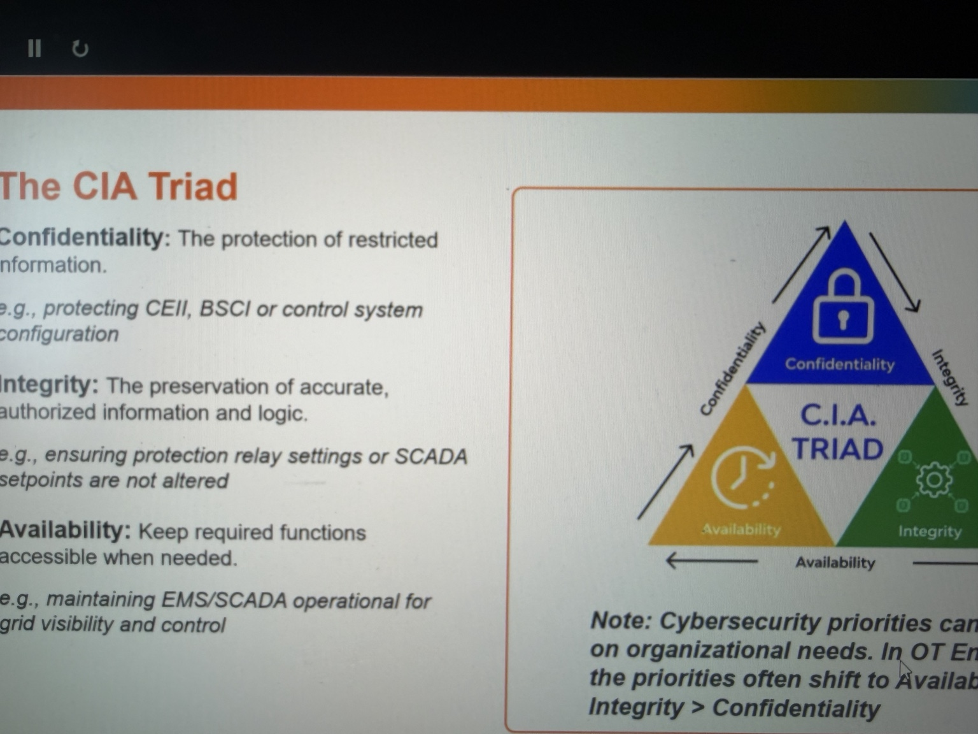

GENERAL TALKING POINTS
- Confidentiality: sensitive information should be accessible only to authorized people.
- Integrity: information and transactions should stay accurate and free from unauthorized changes.
- Availability: authorized people should be able to use services when they need them.
- Use one business example: customer records exposed, a payment detail changed, or an application taken offline.
- Transition question: Who tries to defeat these protections, and what methods do they use?

PRESENTER SCRIPT / NOTES
0:00–0:40 | Three different ways a system can fail
The CIA triad describes what we protect: confidentiality, integrity, and availability. These are three different questions, not three software products. Confidentiality asks who can see information. Integrity asks whether information can be trusted. Availability asks whether authorized users can use a service when they need it. An incident may affect one, two, or all three. Imagine a company using an online system to manage customer accounts and payments. The same application can experience very different security failures, depending on what an attacker does.
0:40–1:45 | Confidentiality: information seen by the wrong person
Start with confidentiality. A customer service employee might need access to contact details to complete a task, but that does not mean every employee should export the entire customer database. If someone steals an account and downloads private records, confidentiality has been compromised. The application may still work and the data may still be correct, but the wrong person has seen it. Controls include least-privilege access, strong authentication, appropriate encryption, and rules for handling sensitive information. Human error matters too: an email sent to the wrong recipient or a publicly shared folder can expose data without malware. Ask: who needs access, and how could we detect access by someone else?
1:45–3:05 | Integrity: the information itself is changed
Now suppose the attacker does not steal data. Instead, they gain access to accounts payable and change the bank account on a vendor record. The invoice still exists, and the payment system still works. The problem is that the information cannot be trusted. An employee might approve a payment believing it will reach the correct supplier. That is an integrity failure. Integrity also matters for permissions, software updates, inventories, audit logs, and financial totals. Controls include change approval, separation of duties, version histories, and logging. For example, if a supplier emails asking to change payment instructions, an employee should verify the request through an independently known contact, not reply to the suspicious message. A change can look completely ordinary on a screen and still be unauthorized. The questions to ask are: who changed it, was the change approved, and can we verify the current value? Integrity protects the accuracy of the information people use to make decisions.
3:05–4:00 | Availability: the service cannot be used
Finally, suppose ransomware encrypts the billing department's shared files, or its customer portal goes offline. No information needs to be stolen or changed for the interruption to matter. Employees may be unable to send invoices, answer questions, or retrieve important records. That is an availability problem. Organizations improve availability through resilient systems, tested backups, incident response, and recovery plans. A backup has value only if it can actually be restored in time to support the business. Notice the distinction: a data leak threatens confidentiality, a false payment detail threatens integrity, and a service outage threatens availability. One incident can threaten all three. Who deliberately causes these failures, what motivates them, and how do they gain access?

Slide 3 | Threat Actors, Techniques, and Tooling
TARGET: 4:30 | FOUNDATIONAL CYBERSECURITY / GUIDED TRANSITIONS
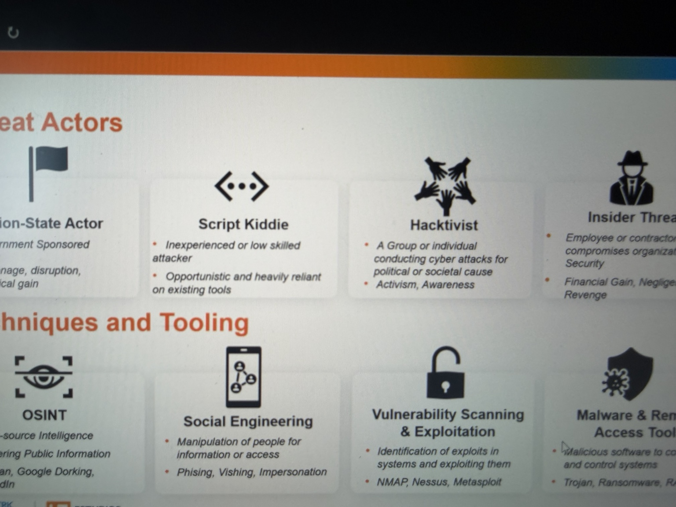

GENERAL TALKING POINTS
- Threat actors differ by motivation, access, capability, and resources.
- OSINT and reconnaissance help attackers choose people, services, and potential entry points.
- Social engineering and phishing often target trust rather than software flaws.
- After initial access, attackers may seek additional privileges, data, or business disruption.
- Transition question: How do cyber risks change when a computer is also controlling physical equipment?

PRESENTER SCRIPT / NOTES
0:00–1:15 | Actors, motivations, and opportunity
A threat actor is a person or group whose actions may compromise information or systems. Some criminals seek money through fraud, stolen data, or ransomware. Nation-state-linked groups may pursue intelligence or strategic goals. Hacktivists may seek publicity or disruption for an ideological cause. Insider threats involve trusted people who deliberately misuse access or accidentally expose information. Less-experienced attackers can also use publicly available tools. The key is not to memorize labels and assume each group behaves the same way. Ask: what does the actor want, and what access or capability do they have? Motivation does not guarantee skill, and skill does not guarantee access. A weak account can be dangerous, but well-enforced permissions can still contain an advanced attacker. For our next example, imagine a business that relies on cloud email, shared files, and a vendor payment portal.
1:15–1:55 | Scenario, step 1: reconnaissance
Before sending anything malicious, an attacker examines public information. Job advertisements may reveal the company's software, professional profiles identify employees in accounting, and the website names a regular supplier. This is open-source intelligence, or OSINT. None of those facts needs to be confidential. Combined, they can help a fake request sound convincing. The attacker learns whom to contact, which supplier name to use, and what an invoice typically looks like. In other words, the attacker prepares a believable story before trying to gain access.
1:55–2:40 | Scenario, step 2: deception and initial access
The attacker sends an email pretending to be that supplier, asking an accounts-payable employee to open an updated invoice. The link leads to a convincing imitation of the usual sign-in page. This is phishing, a form of social engineering that exploits trust. If the employee enters a password, the attacker may try it on the real service. The attempt could fail because of multifactor authentication or account restrictions. A stolen password is not automatic access. But if sign-in succeeds, the next question is: what can that account actually reach?
2:40–3:30 | Scenario, step 3: discovery and attempted expansion
The attacker may search accessible messages and files, look for additional credentials, or try other services. They might exploit a vulnerability or deploy malware. Security teams also use discovery and assessment tools legitimately. For example, Nmap identifies exposed services, vulnerability scanners identify potential weaknesses, and authorized security tests confirm findings. A tool is not inherently malicious; permission and purpose matter. Organizations should understand what services are exposed and correct known weaknesses, rather than leaving discovery entirely to an attacker. Even with an initial foothold, the attack may fail when permissions, segmentation, and monitoring prevent further activity.
3:30–4:30 | Break the attack chain; introduce the next section
Follow the chain: public research, impersonation, stolen credentials, and attempted expansion. Where do defenses help? Employees verify unexpected requests, stronger authentication protects accounts, least privilege limits access, and monitoring detects unusual activity. Incident response provides a plan when prevention fails. These are separate opportunities to stop an attack, not one perfect solution. So far, our examples involve messages, accounts, financial records, and applications. Now change one detail. What if the computer is not simply storing information but also sending instructions to a physical machine? Would the consequences, priorities, and defenses be the same? That brings us to IT and OT.

Slide 4 | Information Technology vs. Operational Technology
TARGET: 3:00 | IT / OT SECTION BEGINS
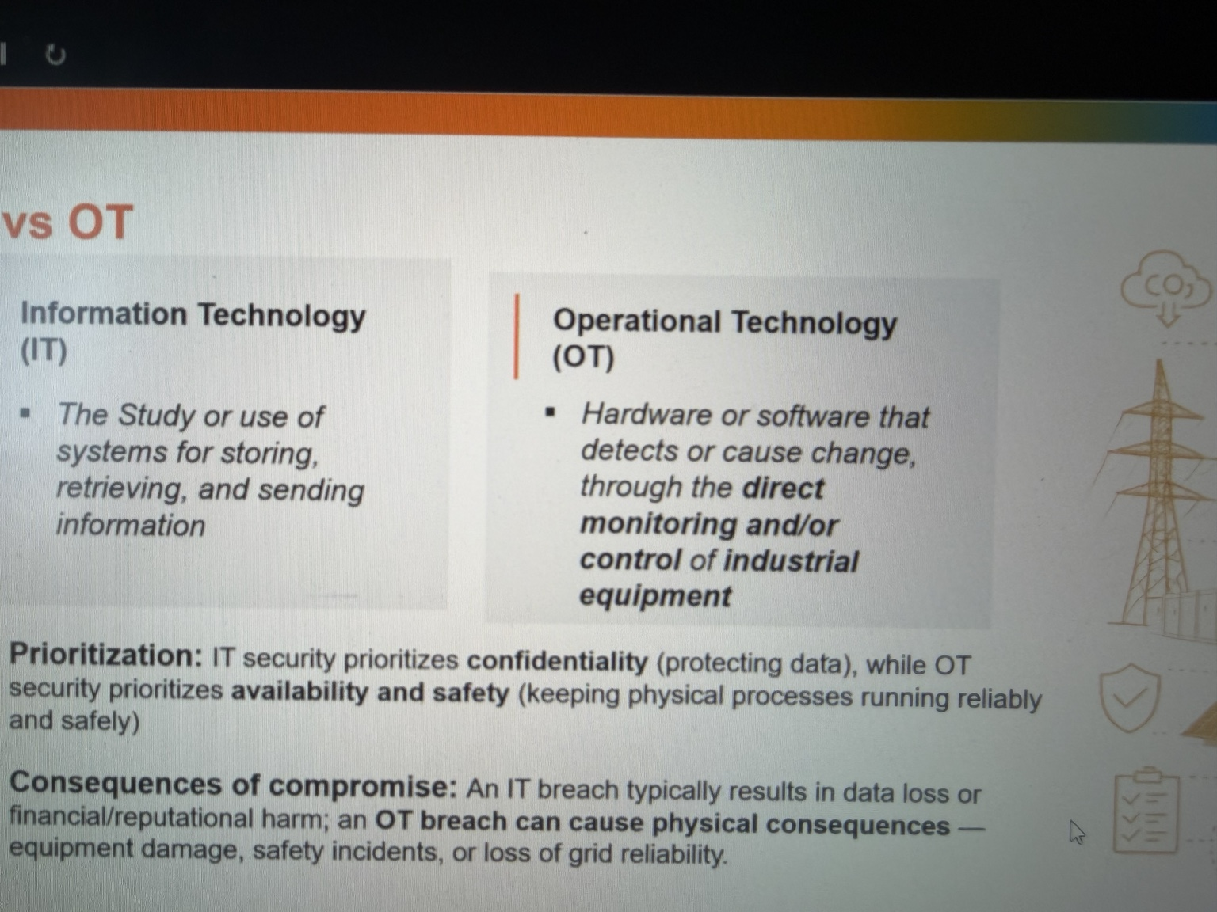

GENERAL TALKING POINTS
- IT manages business information; OT monitors and controls physical processes.
- Sensor → controller/PLC → actuator; HMI presents the operator view.
- SCADA supervises systems; RTUs interface with remote field equipment.
- Protective relays support electrical protection; DCS is another control architecture.
- The correct security approach depends on physical process consequences.

PRESENTER SCRIPT / NOTES
0:00–0:30 | The essential difference
Information Technology, or IT, supports communication, data processing, storage, and business work: email, finance systems, databases, and user workstations. Operational Technology, or OT, monitors and controls physical processes: generation equipment, pumps, valves, breakers, and industrial machinery. Both depend on computing. The distinction is what the technology is being used to do and what happens when it fails.
0:30–2:15 | Walk through a physical control loop
Picture a cooling-water pump at a generating facility. A sensor measures a process condition, such as pressure or temperature. A controller receives that signal, evaluates programmed logic, and sends an output to start equipment, change a valve position, or trigger an alarm. A PLC is one kind of controller that executes such logic. An HMI is the screen an operator uses to view process values, alarms, and controls; the HMI is not the pump itself. SCADA systems gather information and support supervisory monitoring and control, sometimes across distant sites. RTUs are commonly used at remote locations to collect field signals and communicate with supervisory systems. A protective relay has a distinct job: detect electrical conditions and operate protection functions. Different facilities also use DCS architectures rather than stand-alone PLC arrangements. These systems form a chain from measurement, to decision, to physical action. Notice the separation of duties. If an HMI freezes, the underlying PLC may continue executing its programmed control logic, and local protection may still operate. Conversely, a beautifully rendered HMI display does not prove that a field signal or controller setting is correct. An HMI shows information and sends authorized operator requests; it is not the same as the actual physical equipment. Understanding that distinction helps teams diagnose failures and place monitoring at the right points in the process.
2:15–3:00 | Why the difference matters for security
In a corporate environment, if someone locks a file server, the immediate problem may be lost productivity and inaccessible data. In the plant, an unexpected controller output could affect a physical process, while a lost operator screen could reduce visibility. That does not mean every OT cyber event damages equipment, or that IT has no physical consequences. It means cybersecurity decisions in OT must account for safety, timing, engineering constraints, and local fail-safe behavior. Before assessing an OT device, first understand what that device does in the process. If these environments have different purposes, why do organizations connect them at all?

Slide 5 | IT and OT Integration
TARGET: 2:30 | SCENARIO-LED PRESENTER NOTES
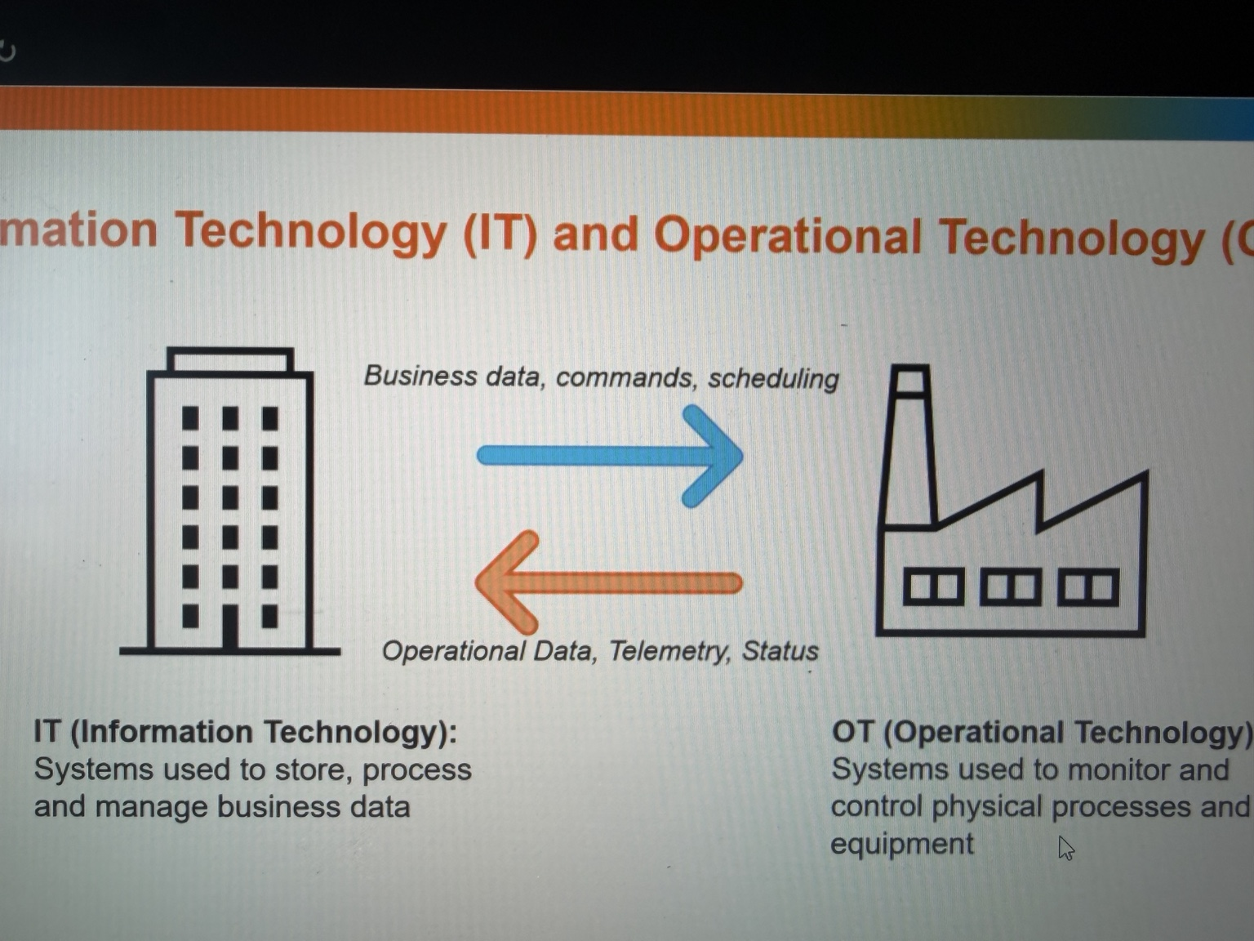

GENERAL TALKING POINTS
- Operations share data with engineering, analytics, maintenance, and business teams.
- Example: OT measurements → historian → approved reporting path.
- The Purdue Model is a useful conceptual guide, not a substitute for a site architecture.
- Use an industrial DMZ and purpose-specific, restricted communications.
- Reporting needs rarely justify unrestricted direct access to controllers.

PRESENTER SCRIPT / NOTES
0:00–0:30 | Why connect these environments?
Plants need information beyond the control room. Engineering wants performance trends, maintenance wants equipment health, and management wants generation reports. A historian can collect process data so teams can study temperature changes, downtime, or equipment performance without querying every controller directly. These business benefits explain why OT and IT exchange information. Connectivity is useful, but the direction and permissions of each connection matter.
0:30–2:00 | Scenario: a historian publishes generation data
Imagine a generator reporting operating measurements to an OT historian. An approved transfer method shares selected data with a service in an industrial demilitarized zone, or DMZ, and then with a reporting system used by the business. The business needs to read a report; it does not need the ability to change a turbine's control logic. Design should therefore distinguish read-only reporting from privileged maintenance or control paths. The Purdue Model provides a useful way to discuss enterprise, supervisory, control, and field functions, although real plant networks do not always map perfectly onto the model. A DMZ and carefully configured firewall rules help mediate traffic between zones. Consider the trust boundary. A maintenance analyst may need to view a month's worth of vibration and temperature history, but should not be able to send commands to a motor starter merely because both systems are on a network. Some architectures use intermediaries, replicated data, or one-way transfer mechanisms where appropriate. The direction of data flow, the access rights, and the protections at each boundary should be based on the actual business requirement, not the easiest available network path.
2:00–2:30 | What to validate
For every IT/OT connection, identify the business purpose, data direction, systems involved, owner, authentication, logging, and failure behavior. Ask whether the data could be shared without giving a corporate workstation direct controller access. Ask what happens if the business network goes down: should the control process continue locally? The design objective is not to eliminate data exchange. It is to make each connection deliberate, bounded, and supportable. Once we create an approved connection, what could an attacker try to do with that pathway?

Slide 6 | IT and OT Connectivity Risks
TARGET: 3:30 | SCENARIO-LED PRESENTER NOTES
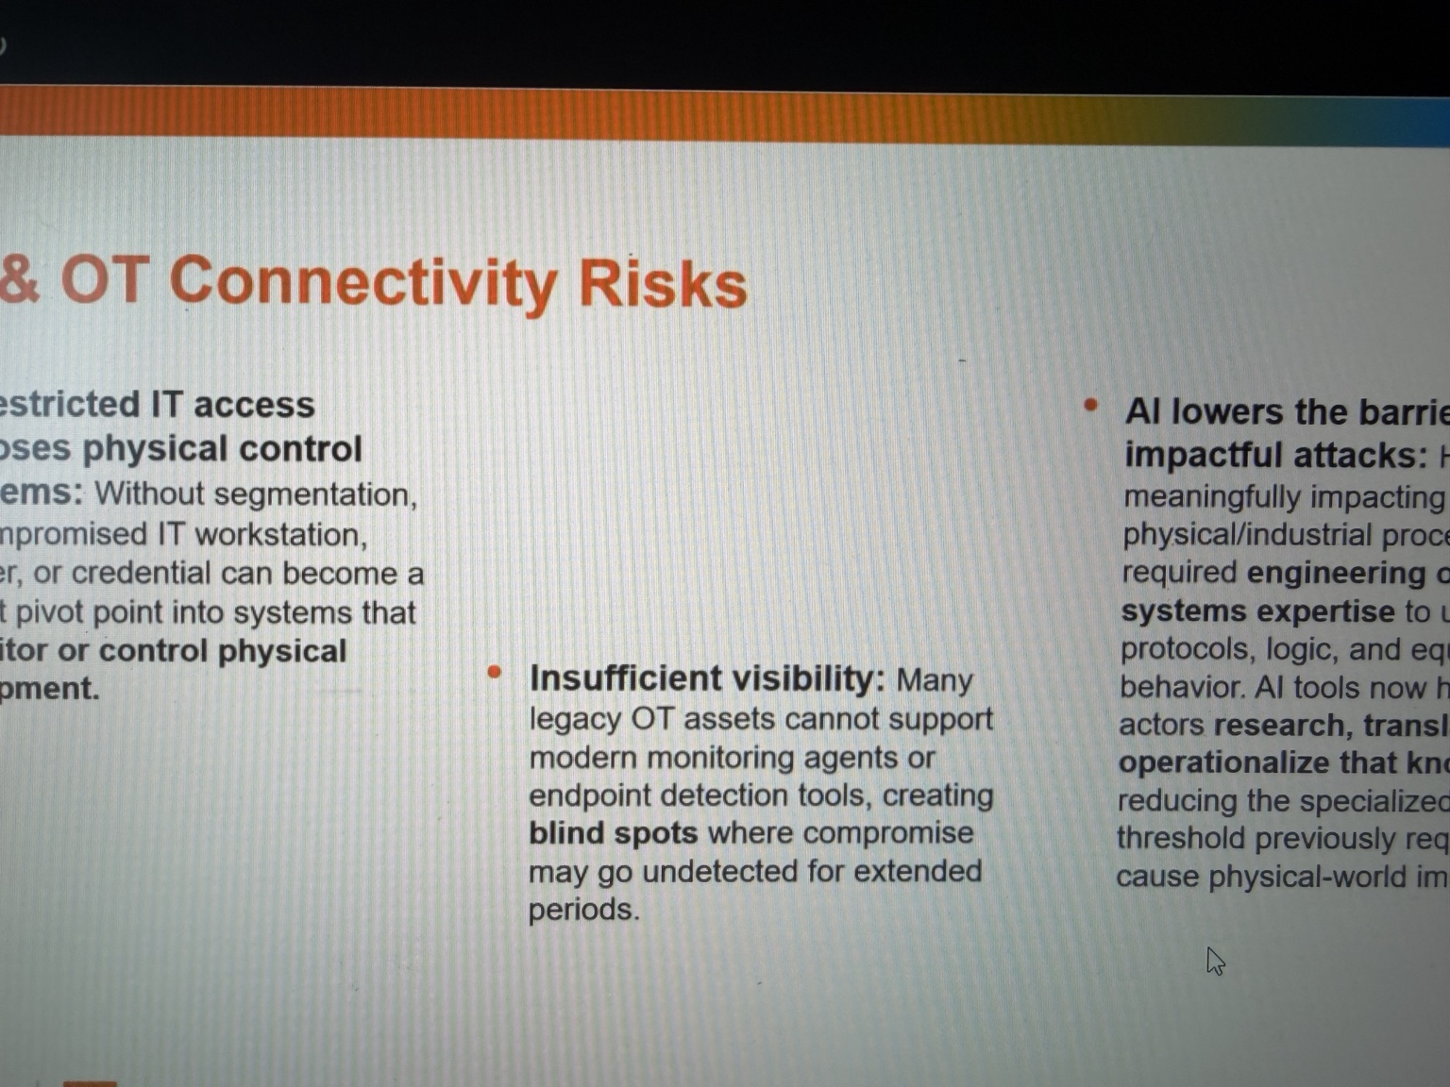

GENERAL TALKING POINTS
- Remote access and IT/OT interconnections increase potential attack paths.
- Trace the chain: phishing → compromised vendor identity → attempted OT access.
- Limit access by person, system, purpose, time, and approval.
- Use segmentation, MFA, controlled gateways, and appropriate monitoring.
- OT scanning and endpoint tooling require engineering and safety review.

PRESENTER SCRIPT / NOTES
0:00–0:35 | A pathway can become an attack path
Every approved connection creates a route for some type of communication. A vendor needs remote access to diagnose a controller; an engineer needs access to settings; a reporting application needs measurements. Those purposes are legitimate. Problems arise when access is always enabled, credentials are shared, accounts remain active after a contract ends, or a firewall permits more than the task requires. The attack surface is the set of opportunities an adversary might attempt to reach.
0:35–1:55 | Scenario: phishing to vendor access
Suppose a vendor technician receives a convincing phishing message and their workstation is compromised. The attacker explores what the technician can reach. If the vendor has an unrestricted VPN into a plant network, the compromised identity or device could provide a route toward operational assets. That is a possible route, not an inevitable compromise of OT. Compare a more controlled design: the vendor first authenticates with MFA, receives time-limited approval, connects to a monitored access gateway, and is permitted to reach only the specific maintenance system. An attacker who steals one password then faces additional controls, and the organization has a clear way to revoke access. Another route sometimes overlooked is an out-of-band remote connection maintained by an integrator for convenience. If it is undocumented, the utility might have excellent firewall rules on its main corporate boundary while an alternate path bypasses those rules. Inventorying remote-access methods, including third-party paths, is therefore as important as reviewing the named VPN. The organization needs to know who can approve access, who can disable it, and how that process works outside normal business hours.
1:55–3:00 | OT monitoring is different
In an office, security teams may install endpoint agents or run routine authenticated scans. Some industrial endpoints do not support these tools or cannot be taken offline easily. Passive monitoring can observe network traffic without actively probing devices; any active scan should be reviewed and tested with operations and the vendor as appropriate. The goal is to learn which devices communicate, whether that pattern changes, and whether a new or unauthorized connection appears. A baseline of known communication patterns can make an alert meaningful. For example, an engineering workstation may normally contact a controller only during approved maintenance. If that workstation begins communicating at midnight or a new host attempts to connect, the change deserves review. The alert alone does not prove malicious activity, but it gives operators and security staff a place to investigate without guessing what normal plant traffic looks like.
3:00–3:30 | Where AI fits
Generative AI can make phishing messages more convincing and help summarize publicly available documentation. It does not automatically give an attacker access to a plant or teach a tool to bypass every safety control. The practical response is the same: reduce exposed pathways, verify remote identities, use least privilege, monitor what is actually happening, and make it possible to disable access quickly without disrupting the process. What if the devices on the other side of those pathways are too old to support normal security updates?

Slide 7 | Legacy OT Environments
TARGET: 3:00 | SCENARIO-LED PRESENTER NOTES
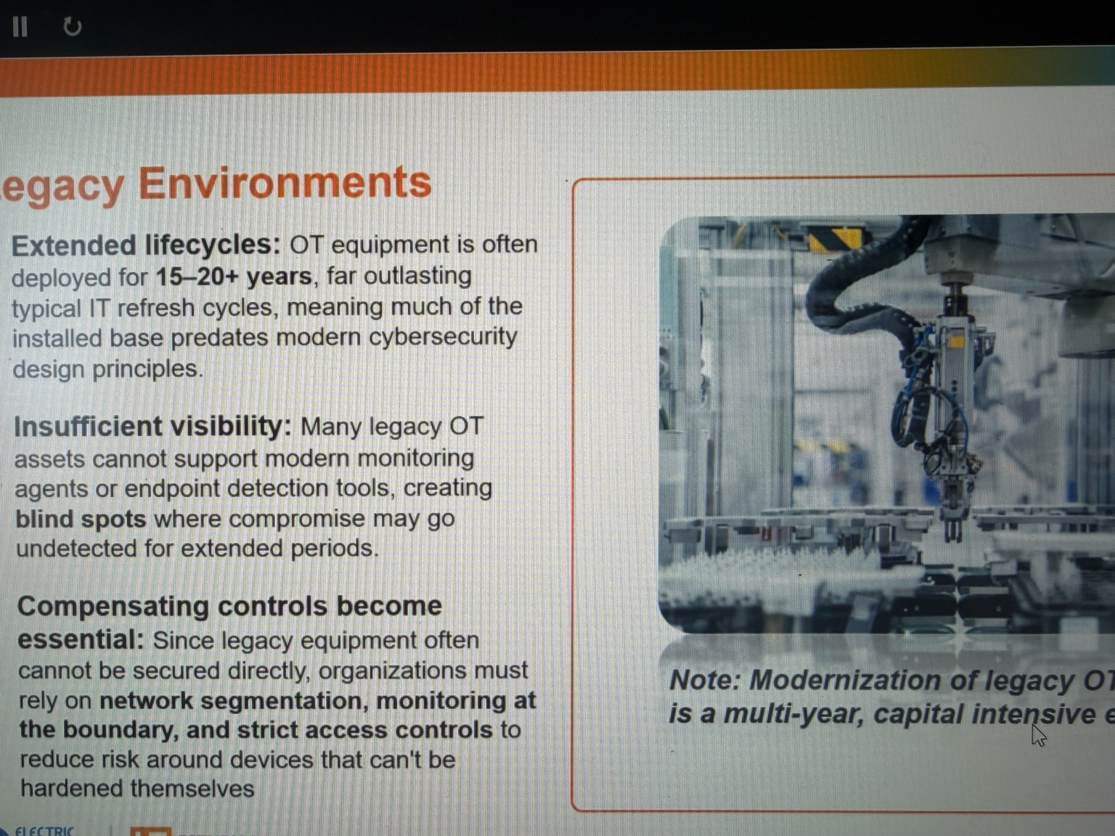

GENERAL TALKING POINTS
- OT equipment may operate for decades and be costly to replace.
- Legacy devices may lack modern authentication, encryption, or vendor support.
- Routine IT patching and active scanning may be unsafe for some OT devices.
- Use engineered compensating controls, documented access, and tested backups.
- Modernization is a risk-based lifecycle and outage-planning decision.

PRESENTER SCRIPT / NOTES
0:00–0:35 | Why older systems remain in service
An industrial controller may perform a stable, essential job for decades. Replacing it can mean redesigning interfaces, checking compatibility, revalidating logic, scheduling an outage, and conducting commissioning tests. A corporate laptop might be replaced every few years; a controller or relay may remain in operation for fifteen, twenty, or more. The age itself is not a vulnerability. The concern is that some older equipment was built without modern authentication, encryption, logging, or supported patching.
0:35–1:55 | Scenario: the unpatchable controller
Imagine a legacy PLC supporting an auxiliary pump. The vendor no longer provides security updates for the controller, but the equipment is reliable and replacement requires a plant outage. A normal IT instinct might be to scan the device aggressively and patch immediately. That could be unsuitable: the controller's protocol stack may be fragile, the patch might not exist, and even a planned restart could affect operations. The right next step is engineering-led assessment. Identify exactly what the controller controls, which hosts communicate with it, and whether it can be separated from less-trusted systems. A practical assessment starts with an inventory and a maintenance conversation. Confirm the exact controller model and firmware, the latest supported configuration, available backups, communication partners, and whether redundancy or manual procedures exist. Operations should identify the consequence of a restart or lost command. Security can then propose controls that do not change the logic in the middle of a production run. The engineers who own the process need to approve the test method and maintenance window.
1:55–3:00 | Compensating controls and lifecycle planning
If the device cannot authenticate remote users directly, put authenticated access controls on the path to it. Restrict network traffic to approved engineering workstations and necessary protocols; log remote sessions; limit physical access; maintain tested backups of configurations; and develop an upgrade plan for a suitable outage window. These are compensating controls: safeguards placed around a system whose own features cannot be quickly changed. The objective is to reduce likelihood and impact while preserving safe, reliable operation. Also plan for recovery rather than only prevention. If a controller fails, can the team obtain a replacement, restore known-good logic, and validate that alarms and interlocks behave correctly? Are configuration files backed up and protected against unauthorized changes? Are current vendor contacts available? Documentation, spare parts, and tested procedures may reduce operational impact even when the underlying older device cannot be updated immediately. If maintaining old equipment creates these constraints, how should we build new systems or upgrade existing ones?

Slide 8 | Security by Design: Brownfield vs. Greenfield
TARGET: 3:00 | SCENARIO-LED PRESENTER NOTES
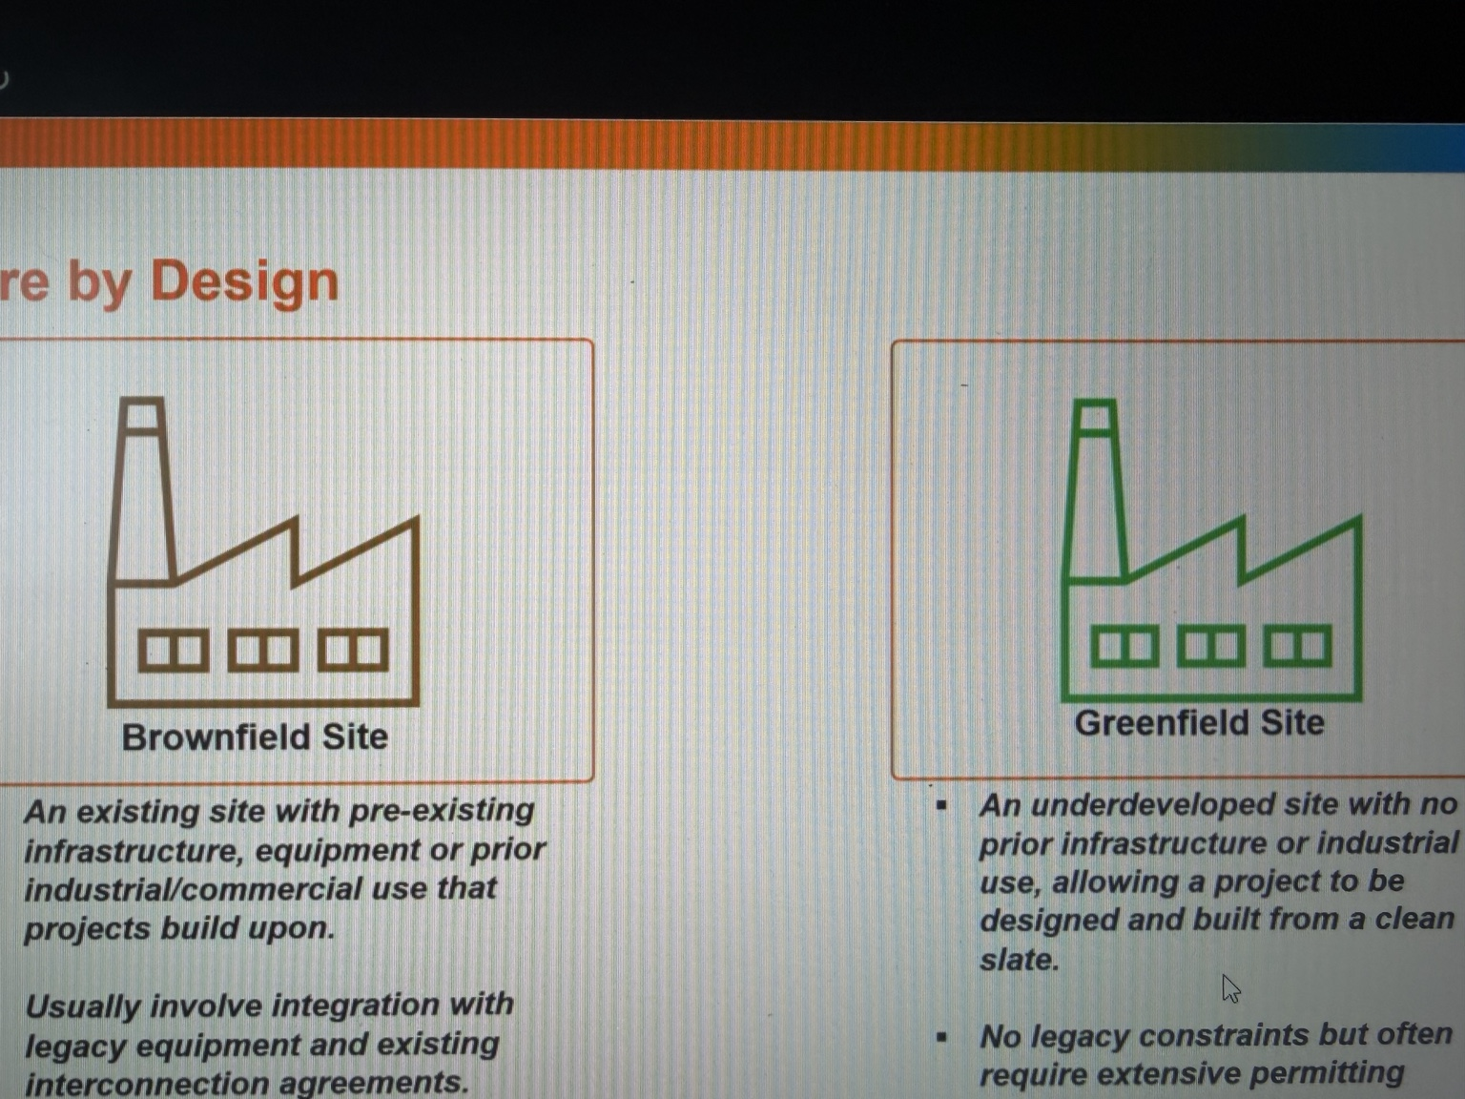

GENERAL TALKING POINTS
- Security by design begins at requirements, procurement, and architecture.
- Brownfield: improve a working facility without disrupting existing processes.
- Greenfield: define access, monitoring, segmentation, and support requirements early.
- Use engineering reviews plus FAT/SAT to validate appropriate security requirements.
- New does not automatically mean secure; existing does not mean unprotectable.

PRESENTER SCRIPT / NOTES
0:00–0:30 | Put security into the engineering process
Security by design means deciding how systems will be protected while they are being specified, purchased, built, and tested. If security is discussed only after commissioning, the facility may already depend on vendor remote access, shared accounts, or equipment that cannot log important events. Fixing those decisions afterward is harder and sometimes requires downtime.
0:30–1:10 | Brownfield: modernize an operating facility
A brownfield project modifies an existing site. Imagine upgrading the control network in a plant that operates every day. The team must preserve connections to existing relays, controllers, displays, and field wiring. Some devices cannot support current protocols or authentication methods. The practical path may be to document existing communications, design new segmentation around legacy components, test changes in stages, and schedule cutovers during approved windows. The security architecture has to respect the facility that already exists.
1:10–2:40 | Greenfield: build requirements before buying equipment
A greenfield project is a new facility or installation. Before a PLC, HMI, switch, or remote-access platform is procured, the project can require supported software, role-based access, network logging, controlled vendor connectivity, and recovery capabilities. Engineering drawings and network diagrams can identify trust boundaries from the beginning. During factory acceptance testing, or FAT, teams can verify selected functionality before delivery; during site acceptance testing, or SAT, they can verify implementation and integration at the site. Cybersecurity checks should be planned and coordinated with the engineering test process rather than assumed to happen automatically. For procurement, a useful test is to turn vague goals into evidence. Instead of writing only 'secure remote access required,' define who approves a session, how authentication works, how permissions are restricted, and what logs must be available. Ask the vendor to demonstrate those functions during an agreed test. Confirm whether insecure default services can be disabled and whether the vendor has a supported method for firmware updates and recovery. A requirement that cannot be verified may not survive commissioning.
2:40–3:00 | Do not confuse new with secure
A brand-new facility can still ship with default passwords or excessive remote access. A brownfield facility can have strong controls through careful upgrades. The advantage of early design is that security requirements become testable engineering requirements instead of an expensive surprise. When many improvements are possible, how do we decide which risks to address first?

Slide 9 | Managing Cybersecurity Risk
TARGET: 3:30 | SCENARIO-LED PRESENTER NOTES
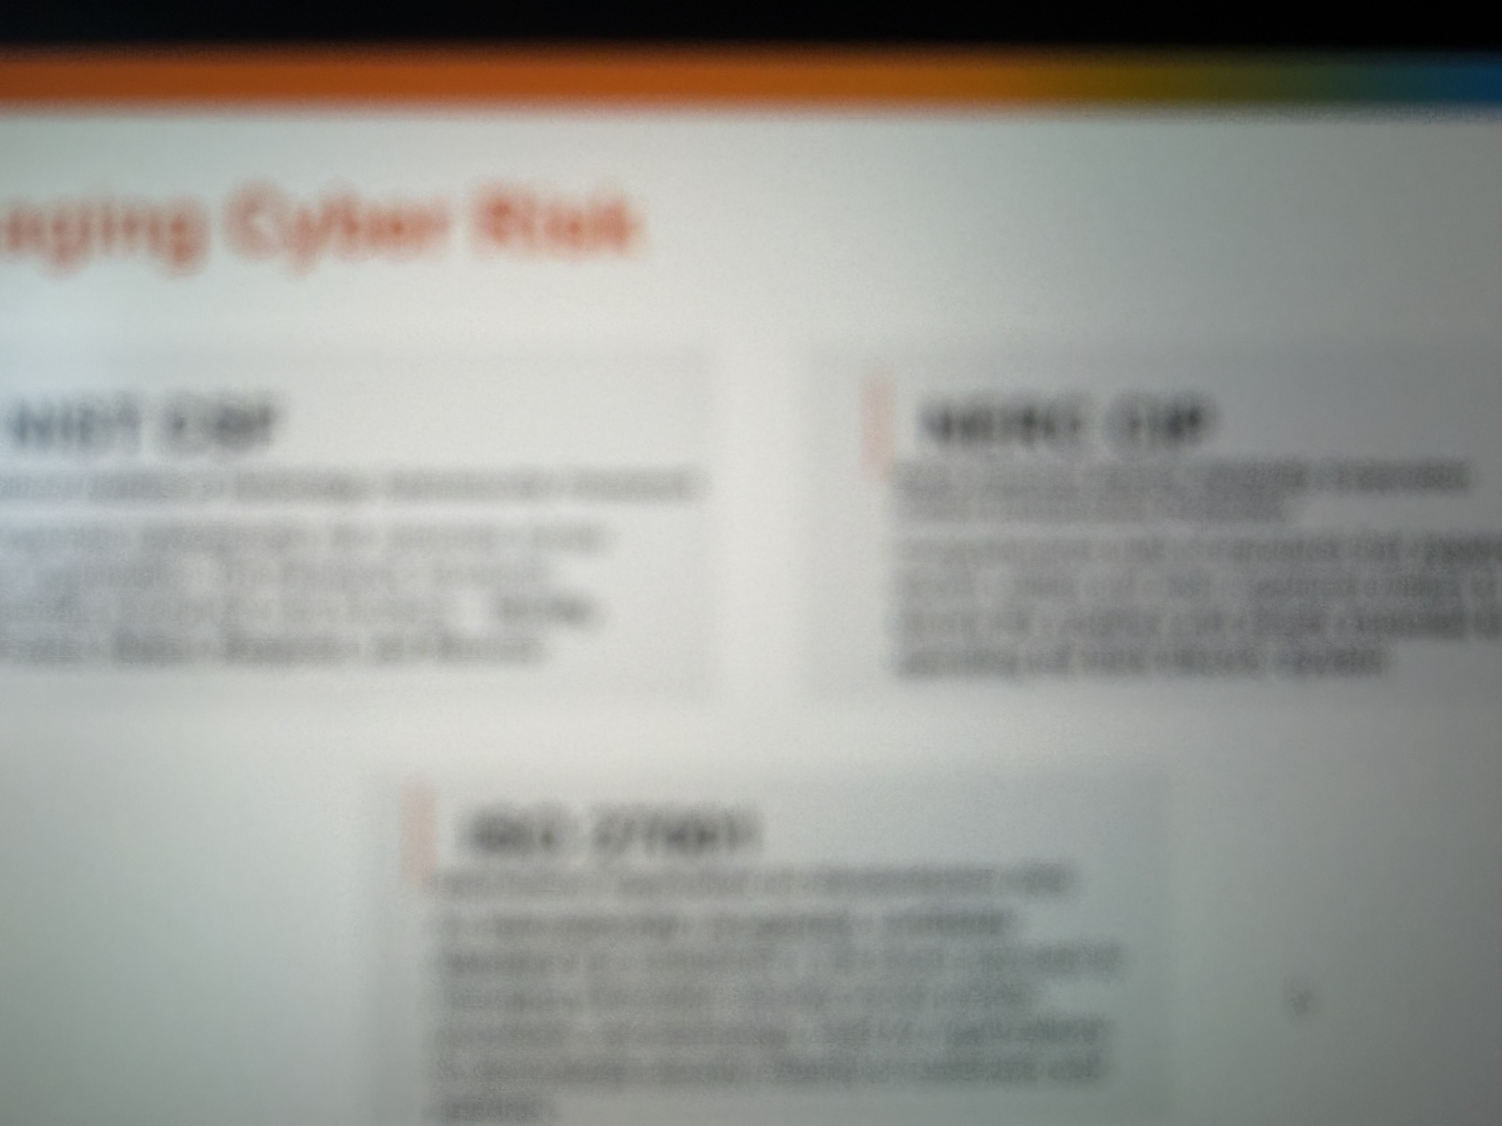

GENERAL TALKING POINTS
- Inventory assets and relate them to actual operational functions.
- Evaluate exposure, threat, vulnerability, existing controls, and consequences.
- Walk through a vendor remote-access request as a real risk decision.
- Choose technical, procedural, and physical controls with clear ownership.
- Use NIST CSF, NIST SP 800-82, and applicable NERC CIP; compliance is not zero risk.

PRESENTER SCRIPT / NOTES
0:00–1:10 | Start with the asset and its consequence
Risk management begins with knowing which assets support which functions. An inventory should do more than name an IP address: identify the system owner, device role, location, communication dependencies, software or firmware information as appropriate, and the process it supports. Consider two computers with the same outdated software. If one produces a low-priority report and the other is necessary for a critical operator function, the consequences of compromise are different. Security priorities should reflect the consequence, the feasible attack pathways, and existing safeguards. To describe risk consistently, separate a threat from a vulnerability and an impact. A stolen credential is one possible attack method. Excessive permission is a weakness that can make it useful. The impact depends on the systems reachable through that permission. A simple risk record should name the owner, affected assets, scenario, controls already present, actions to reduce exposure, and when the organization will review the decision again. That turns an abstract concern into trackable work.
1:10–2:05 | Scenario: vendor access risk assessment
A generator's maintenance vendor requests remote access to troubleshoot equipment. First define the business need: what device requires support, and why can the work not be performed through a lower-privilege method? Next identify exposure: is access permanent or approved per session; are personal accounts and MFA required; can the vendor reach the entire OT network or only one maintenance host? Then consider the threat: an attacker could steal credentials or compromise the vendor's workstation. Finally, estimate impact: what functions could the account reach, and would unauthorized actions affect equipment availability, integrity, or safety? Mitigations might include time-bound approvals, an access gateway, segmented destinations, session recording where suitable, periodic account review, and a procedure to revoke access. The remaining risk is then documented and assigned to an accountable owner.
2:05–3:30 | Frameworks, responsibilities, and close
Frameworks help organize the work. The NIST Cybersecurity Framework gives organizations a common structure for governing, identifying, protecting, detecting, responding, and recovering. NIST SP 800-82 provides OT-specific security guidance. Applicable NERC Critical Infrastructure Protection requirements establish mandatory obligations for certain electric-sector entities and systems; scope must be determined rather than assumed for every OT asset. Compliance evidence is important, but a compliant checklist does not prove that every attack path is closed. The operating habit to carry forward is simple: for a new asset, connection, vendor, or change, ask what it does, who can access it, what could go wrong, and how the organization would detect and respond. Cybersecurity risk is managed through those practical decisions, made repeatedly. Incident preparation should connect security procedures with plant operations. If a suspicious connection appears during generation, cybersecurity staff cannot simply disconnect equipment without understanding the process. Operations and engineering should know how to assess safe isolation, preserve logs, use alternate communications, and return systems to service. The most effective plan identifies decision-makers before a crisis. That collaboration is the same theme running through every slide: understand the process first, then select the controls that protect it.

Presenter reference material
Mike Holcomb, Getting Started in OT/ICS Cybersecurity 2026 (Module 3): PLCs, HMIs, and Others Explained, YouTube (July 2026). https://www.youtube.com/watch?v=UJntDz98u3w
NIST SP 800-82 Rev. 3, Guide to Operational Technology (OT) Security. https://csrc.nist.gov/pubs/sp/800/82/r3/final
NIST Cybersecurity Framework 2.0. https://www.nist.gov/cyberframework
Presenter caution: All scenarios are illustrative, not claims that one weakness automatically causes a real-world outage. NERC CIP applicability must be assessed case by case.

